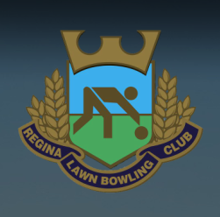

**Regina Lawn Bowling Club**

**Open House**

**Saturday, May 18, 2019**

**10:00am – 4:00pm**

**Victoria Avenue & Queen Street**

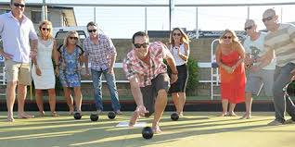

<http://reginalawnbowlingclub.ca/>

rlbc.sk@outlook.com